A

Project Report

On

**“Restaurant Management System**”

For the partial fulfillment of IV semester Apprentice Project

(BIT 256CO) for the requirements of Bachelor in Information Technology

(BIT) Awarded by Purbanchal University



**Submitted To**

**Purbanchal University**

**Biratnagar, Nepal**

**Submitted By:**

Nischal Pandey

Samrakshyan Lamichhane

Himalayan White House International College (HWIC)

Putalisadak, Kathmandu

# 

# Approval Certificate

This is to certify that this project work entitled **“Restaurant Management System**” submitted by Mr. Nischal Pandey and Samrakshyan Lamichhane is a work carried out under our supervision and guidance fulfilling the nature and standard required for the partial fulfillment of the degree of Bachelor in Information Technology.

------------------------ -----------------------

(Er. Bimal Sharma) (Er. Nirajan Hamal)

HOD, BIT Supervisor

HWIC HWIC

# Acknowlegdements

We are pleased to acknowledge to our respected instructor Er. Nirajan Hamal for his invaluable guidance during the course of this project work without his guidance, this project would have been an uphill task.

We extend our sincere thanks to Er. Bimal Sharma, Head of Department (Bachelor in Information Technology), HWIC who continuously helped us throughout the project.

We are very much thankful to Prof. Toya Narayan Poudel, Principal, HWIC for providing facilities which helped in completion of this project.

Last but not least, a great deal of appreciation and best wishes to all my friends for their contribution & encouragement during the work.

Nischal Pandey()

Samrakshyan Lamichhane()

# Abstract

The Restaurant Management System is a Java based system designed to streamline and enhance the operations of Restaurants and similar establishments. With the growing demand for efficient management tools in the food service industry, the Restaurant Management System offers a user-friendly interface that empowers Restaurant owners and staff to effectively manage various aspects of their business.

The system provides modules for inventory management, order processing, customer relationship management , and financial tracking. Through a centralized dashboard, Restaurant administrators can monitor stock levels in real-time and place orders with suppliers.

Order processing features enable staff to efficiently take and process customer orders, whether for dine-in. The system supports customization of menu items, modifiers, and pricing, ensuring accuracy and flexibility in meeting customer preferences.

In conclusion, the Restaurant Management System offers a comprehensive solution for Restaurants seeking to improve operational efficiency, enhance customer experience, and achieve business success in a competitive market landscape.

# List of Figures

Figure 1: DJU Catering

Figure 2: Waterfall Model

Figure 3: Context Diagram

Figure 4: Data Flow Diagram

Figure 5: Use-Case Diagram

Figure 6: Sequence Diagram

Figure 7: Activity Diagram

Figure 8: Gantt Chart

Figure 9: Sign in

Figure 10: Sign up

Figure 11: Order

Figure 12: Bill

Figure 13: Admin

Figure 14: Manage Product

# List of Abbreviation

RDBMS: Relational Database Management System

IDE: Integrated Development Environments

SVN: Subversion

DFD: Data Flow Diagram

SDLC: Software Development Life Cycle

RMS: Restaurant Management System

# Table of Contents

Approval Certificate 2

Acknowlegdements 3

Abstract - 1 -

List of Figures - 2 -

List of Abbreviation - 3 -

Table of Contents 1

Chapter 1: Introduction 3

1.1: Background 3

1.2: Problem Statement 4

1.3: Project Objectives 4

1.4: Project Scopes 5

1.5: Project Limitations 5

Chapter 2: Literature Review 6

2.1:Background 6

2.2: Research Based On Similar Project 6

2.3: Functional and Non-Functional Requirement 8

2.3.1: Functional Requirements 8

2.3.2:Non-Functional Requirements 8

2.4: Feasibility Study 9

2.4.1: Technical Feasibility 9

2.4.2: Economic Feasibility 9

2.4.3: Operational Feasibility 9

2.4.4: Time Feasibility: 9

Chapter 3: System Analysis 10

3.1: Software Development Life Cycle 10

3.1.1: Used Model 10

3.2: Context Diagram 11

3.3:Data Flow Diagram 12

3.4:Use case Diagram 13

3.5:Sequence Diagram 14

Chapter 4: Implementation 16

4.1: Software and Hardware Requirement 16

4.1.1: Language Used 16

4.2: Testing 17

4.2.1: Test Cases For Testing Method 17

Chapter 5: Analysis and Evaluation 18

5.1: Analysis of output obtained 18

5.2: Schedule analysis: Gantt Chart 19

Chapter 6: Conclusion and Future Recommendation 20

6.1: Problem Faced and Their Implementation 20

6.2: Conclusion 21

6.3: Future Recommendations 21

Reference 22

Appendices/Annex 23

# 

# Chapter 1: Introduction

## 1.1: Background

The Restaurant Management System project is a Java-based application developed to streamline the operations of Restaurants, enhancing efficiency and improving customer service. The system provides a user-friendly interface for Restaurant owners and staff to manage inventory, process orders and maintain customer relationships.

Restaurant management involved manual processes for tasks such as inventory management, order processing, customer engagement, and financial tracking. However, as Restaurants grow in popularity and complexity, these manual methods often prove to be time-consuming, error-prone, and limiting in terms of business insights.

With the rise of digitalization and the increasing demand for convenience, Restaurant owners and managers are seeking innovative solutions to simplify operations while maximizing profitability. The Restaurant Management System addresses these needs by integrating a range of functionalities into a single, user-friendly platform.

## 1.2: Problem Statement

Existing Problems:

* Mistakes are made when taking the orders of the customers.
* The process of collecting customers’ purchases order is very tedious. This makes it impossible to deliver goods on time.
* It leads to lack of understanding between the customers and the employees.
* The record keeping system is poor. Loss of vital records has been reported in the past consequently. Besides, protecting the file system from unauthorized access is a problem that has defiled solution.
* Unnecessary time is wasted conveying information through the ladder of authority. Management at times seeks to get a copy of the customer’s order form and this may take a lot of time to obtain it.
* It causes reduction of production flow.

## 1.3: Project Objectives

Objectives:

* Develop a user-friendly interface for Restaurant staff to efficiently take customer orders.
* Provide customization options for menu items, modifiers, and pricing.
* Implement secure login mechanisms for administrators, staff, and customers with role-based access control.
* Design an intuitive and responsive user interface for easy navigation and accessibility.

## 1.4: Project Scopes

The project work is narrowed down to Restaurant. It deals with the design, documentation, and implementation of a computerized fast-food restaurant management information system. The program will concentrate on keeping records of the total management activities. Customers will also be able to register view product menus and be able to have a visual confirmation that the order was placed correctly.

## 1.5: Project Limitations

1. **Training and Adoption:**

* Staff training required for effective use of the RMS.

1. **Maintenance and Support:**

* Ongoing maintenance required for updates, bug fixes, and improvements.
* Availability of technical support and resources for troubleshooting.

1. **Customization:**

* Limited customization options within the predefined scope of the project.
* Requests for additional features may require extra development time and resources.

# Chapter 2: Literature Review

## 2.1: Background

**Case Study 1: Internet application for restaurant industry**

According to Nich (1999), today's restaurants are the most significant enterprises in a developed country. The restaurant sector is the third biggest in the United States, with approximately 25% of retail shops being eating or drinking facilities, employing 5% of the total. Furthermore, according to Palmer (1999), the internet is a significant application in the development of this business since it allows restaurants and customers to engage. The internet has evolved into a formidable marketing and communication tool for businesses. Nonetheless, Schneider and Perry (2001) claim that for new business prospects-often known as e-business or e-commerce today. According to Flynn et al. (2005), internet ordering is a critical service in the restaurant sector today. Currently, the restaurant is using a traditional ordering method. This old approach makes it difficult for waiters to manage a portion of a customer's order. Furthermore, it may be a challenge for the restaurant's administrator in terms of storing client information, and it is possible that the information will be lost. To address this issue, the restaurant sector anticipates a rapid surge in online ordering. The internet is becoming more popular, and public access to the internet is becoming easier and more convenient. The computerized system is utilized in the restaurant sector to make restaurant administration easier and more efficient. Furthermore, this initiative aims to transform the old system into a computerized system that is more methodical, productive, and accessible.

## 2.2: Research Based On Similar Project

DJU Catering:

DJU Catering is a seasoned organization with a diverse range of abilities. DJU Catering is prepared to accept food orders for events such as weddings, charity night banquets, meetings, and seminars. DJU Catering also offers online ordering. To place an order online with the DJU catering restaurant, the customer must give all the necessary ordering information in addition to their personal information. DJU Catering will get the information and will call the customer for confirmation.

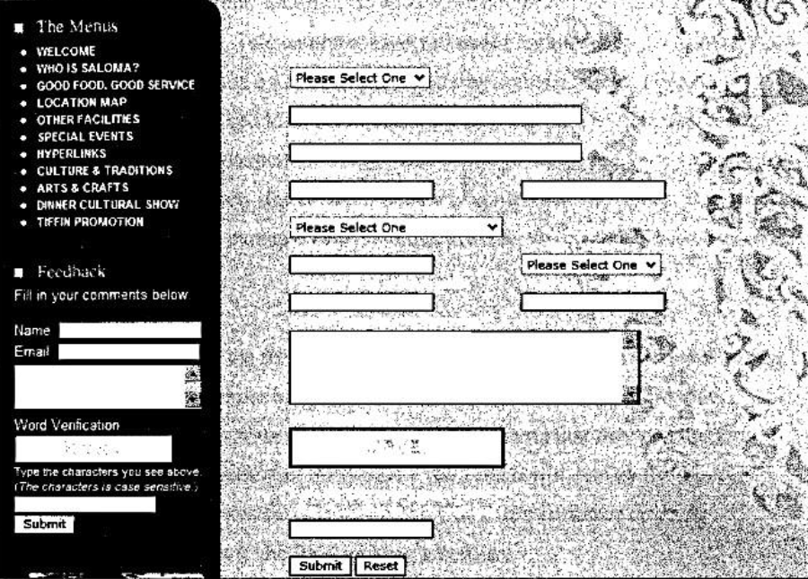

*Figure 1:DJU Catering*

## 2.3: Functional and Non-Functional Requirement

### 2.3.1: Functional Requirements

Functional requirements define the capabilities and functions that a system must be able to perform successfully. The functional requirements of this restaurant management system include:

* The system shall enable the customer to view the products menu, create an account, login to the system and place an order.
* The system shall display the food items ordered, the individual food item prices and the payable amount is calculated.

### 2.3.2:Non-Functional Requirements

A non-functional requirement is a requirement that specifies criteria that can be used to judge the operation of a system, rather than specific behaviors. Some of the non-functional requirements include:

* Backup- provision for data backup
* Maintainability- easy to maintain
* Performance/ response time- fast response

## 2.4: Feasibility Study

The feasibility analysis evaluates the viability of the Restaurant Management System project from technical, economic, operational, and time perspectives. This analysis helps assess the project's feasibility and identify potential risks and challenges that need to be addressed.

### 2.4.1: Technical Feasibility

Technical feasibility assesses whether the project can be successfully implemented using available technologies, tools, and resources. It considers factors such as the compatibility of chosen technologies, the availability of skilled personnel, and the feasibility of integrating with existing systems.

### 2.4.2: Economic Feasibility

Economic feasibility evaluates the cost-effectiveness of the project, taking into account the anticipated costs and benefits over its lifecycle. It involves cost-benefit analysis and budget considerations to determine whether the project is financially viable and justifiable.

### 2.4.3: Operational Feasibility

Operational feasibility examines the project's impact on existing processes, workflows, and organizational culture. It assesses the readiness of stakeholders to adopt and utilize the system effectively, considering factors such as training needs, change management, and stakeholder engagement.

### 2.4.4: Time Feasibility:

Time feasibility evaluates the project's timeline and deadlines to determine whether it can be completed within the desired timeframe. It involves developing a project schedule, setting milestones, and identifying critical paths to ensure timely delivery of the system.

# Chapter 3: System Analysis

## 3.1: Software Development Life Cycle

In the context of a Restaurant Management System , the Software Development Life Cycle (SDLC) refers to the process followed to design, develop, test, deploy, and maintain the Restaurant Management System application. The SDLC model chosen for developing a Restaurant Management System can significantly impact the project's success, efficiency, and quality. Using an SDLC model, such as Waterfall, in a Restaurant Management System helps ensure a structured and systematic approach to developing the software. This is crucial for managing the complexity of the project, coordinating the efforts of the development team, and meeting the specific requirements of the Restaurant system.

### 3.1.1: Used Model

The waterfall model is a sequential design process, often used in software development processes, in which progress is seen as flowing steadily downwards (like a waterfall) through the phases of Conception, Initiation, Analysis, Design, Construction, Testing and Maintenance. The researcher chose Waterfall model because of its certain advantages as can be seen below:

* This model is simple and easy to understand and use.
* The waterfall model is the oldest and most widely used paradigm for software engineering.

.

*Figure 2: Waterfall model*

**Requirements**

**Design**

**Implementation**

**Verification**

**Maintenance**

## 3.2: Context Diagram

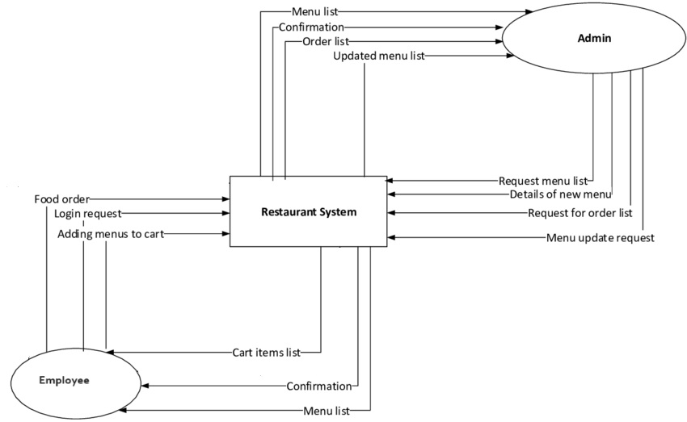

*Figure 3: Context Diagram*

## 3.3:Data Flow Diagram

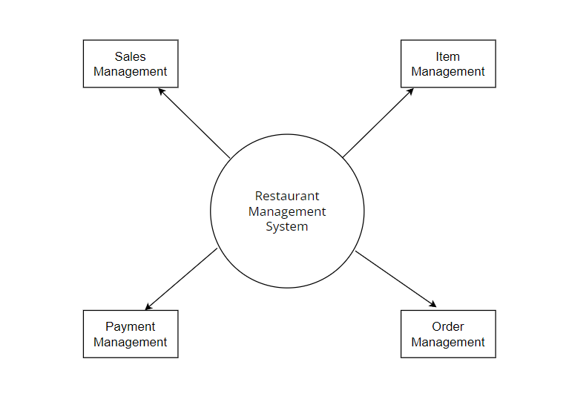

*Figure 4: DFD*

## 3.4:Use case Diagram

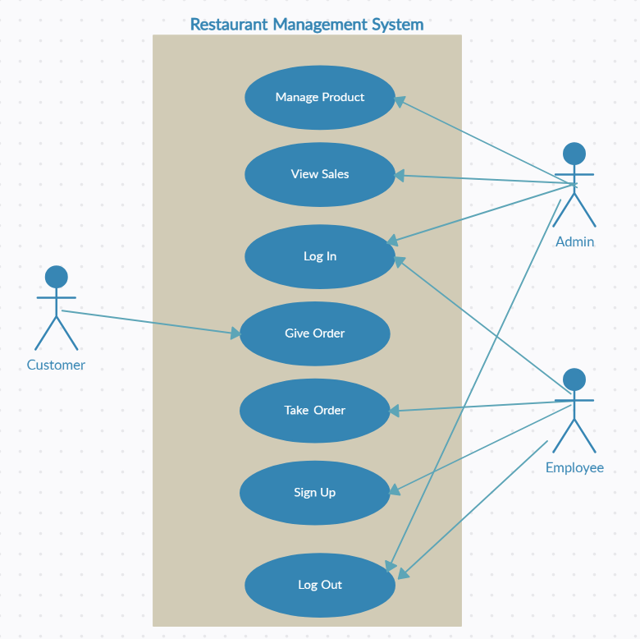

*Figure 5: Use-Case diagram*

## 3.5:Sequence Diagram

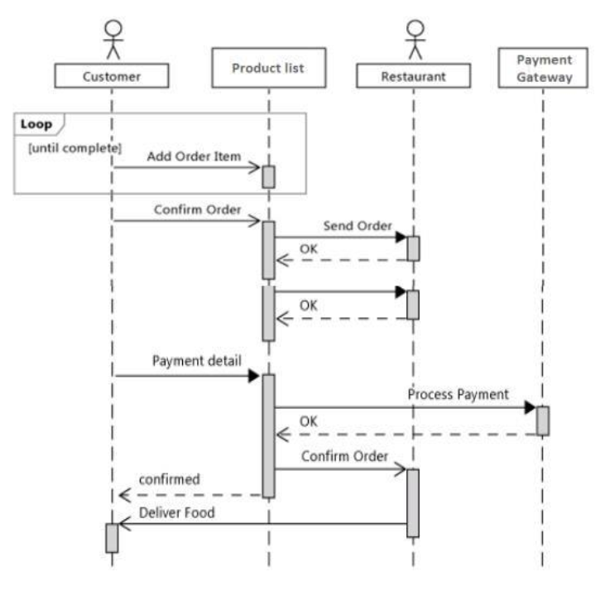

*Figure 6:Sequence diagram*

## 3.6:Activity Diagram

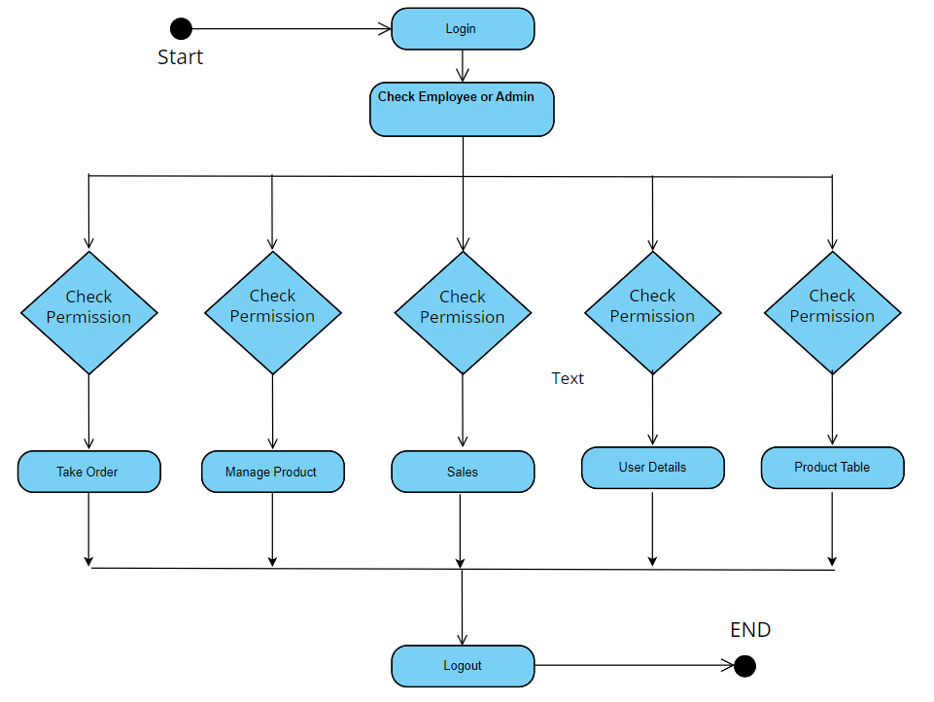

*Figure 7: Activity Diagram*

# **Chapter 4: Implementation**

## 4.1: Software and Hardware Requirement

Computer system is made up of units that are put together to work as one in order to achieve a common goal. The requirements for the implementation of the new system are:

* **The Hardware**
* **The Software**

**Hardware Requirements:**

These are the physical component needed by the system to operate.

* 500mb of Ram(Minimum)
* Keyboard
* Mouse
* Printer
* Intel Pentium

**Software Requirements:**

* Processor speed- 1.30Hz and above
* Web browser
* Xampp control panel
* Operating system

### 4.1.1: Language Used

In a Java project for a restaurant management system, the language used would primarily be Java, as it's the programming language for developing the project. However, besides Java, several other languages and technologies might be utilized depending on the specific requirements of the project:

1. **Java**: The core language for developing the project, including backend logic, business rules, and data processing.
2. **SQL (Structured Query Language)**: Used for database management and interacting with a database management system (DBMS) such as MySQL. SQL is crucial for creating and querying databases to store and retrieve restaurant-related data like menu items, customer information, orders, etc.

## 4.2: Testing

Testing for the Restaurant Management System involves verifying its functionality, reliability, security, and performance to ensure that it meets the requirements and expectations of users and stakeholders.

### 4.2.1: Test Cases For Testing Method

1. **Unit Testing:**

In this approach, each individual program modules of the system were tested separately.

* Testing the registration/login page to allow login
* Testing the add food and the category.
* Testing each component on the admin site.
* Testing each component on the customer site.

1. **Integration Testing**

In this approach, the program modules of the system were integrated and tested as the whole.

* The back button which leads you to the previously opened page,
* Checking whether the all buttons on the admin panel are working and displaying options.

1. **Regression Testing:**

This approach involved checking to see if the addition of one feature is negatively affecting other features.

* Constantly inputting wrong data in login page causes the entire application to force close.

# Chapter 5: Analysis and Evaluation

## 5.1: Analysis of output obtained

## 5.2: Schedule analysis: Gantt Chart

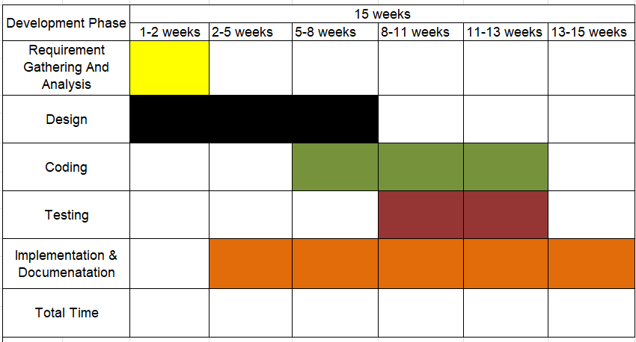

*Figure 8: Gantt Chart*

# Chapter 6: Conclusion and Future Recommendation

## 6.1: Problem Faced and Their Implementation

In a restaurant management system project, various challenges may arise during development and implementation. Here are some common problems faced and potential solutions:

1. **Poor Performance**: The system may experience slow response times, especially during peak hours or when handling large volumes of data.

Implementation: Use efficient algorithms and data structures to optimize performance. Implement caching mechanisms to store frequently accessed data and reduce database queries.

1. **Data Inconsistency**: Due to concurrent access and updates, data inconsistency issues may occur, leading to discrepancies in information stored in the database.

Implementation: Implement transaction management to ensure atomicity, consistency, isolation, and durability (ACID properties) of database operations. Use database locking mechanisms to prevent concurrent modifications to critical data.

1. **User Interface Complexity**: The user interface may be overly complex or difficult to navigate, leading to user frustration and decreased productivity.

Implementation: Conduct user research and usability testing to understand user needs and preferences. Design intuitive and user-friendly interfaces with clear navigation and consistent layout.

## 6.2: Conclusion

In conclusion, the project’s goal was achieved, which was design and implemented. The program was tested and it achieves the desired objectives. The application interface was made user friendly in such a way that even a novice computer user will not have difficulty in using the system. However, a lot of challenges were faced during the process of implementing the system. Designing a system that will handle interactive communication between the system users and the system administrators is a time consuming and complex task. Also, while coding, an error might occur, either syntax or logical, getting away with such errors is not an easy task. The most challenging task is removing such errors, because a single error usually takes me an averagely some hours or a day before I find a way of overcoming the error.

## 6.3: Future Recommendations

The system would not be able to send some notification about any report to customer and once a customer’s order is placed, the order cannot be cancelled or edited. So as often happens, some ideas and improvements still remain to be completed. The following are the possible future work:

* Extend the system to allow cancellation of orders by the customers when needed.
* Send an order ready notification to customer.
* Add different payment option for the system like cash, PayPal and to allow save payment details for future use.

# Reference

Bowen & Morris’s (2013). *Influence of technology on restaurants and how products are displayed on menu.*

Spalding, and Ives (2001). *Satisfaction of customers with the use of technology, internam and external factors.*

# Appendices/Annex

**1. Sign in**

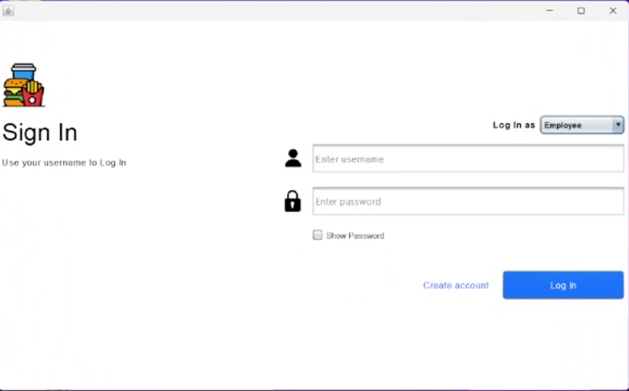

*Figure 9: Sign in*

**2. Sign Up**

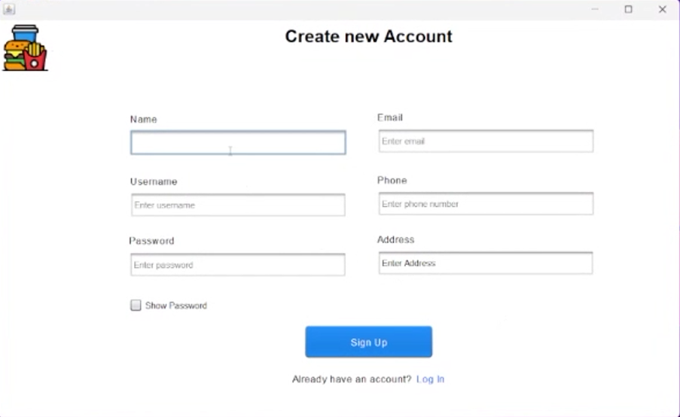

*Figure 10 : Sign up*

**3. Order**

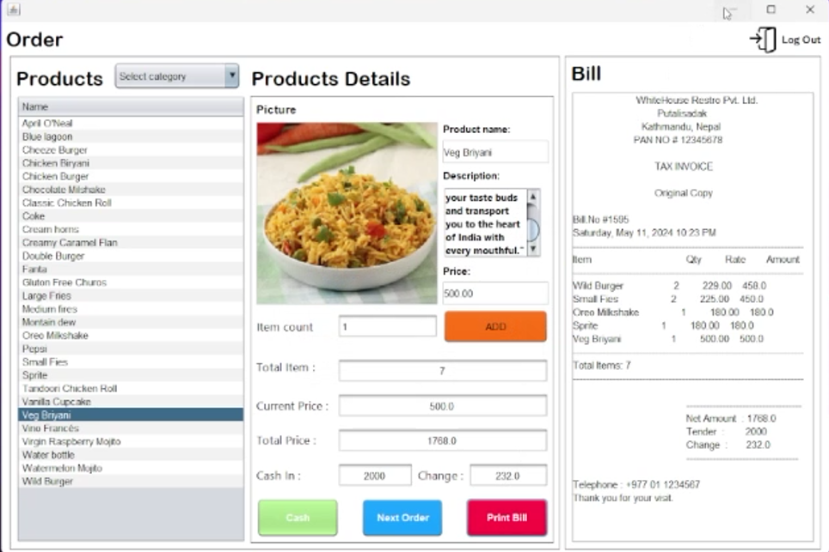

*Figure 11: Order*

**4. Bill**

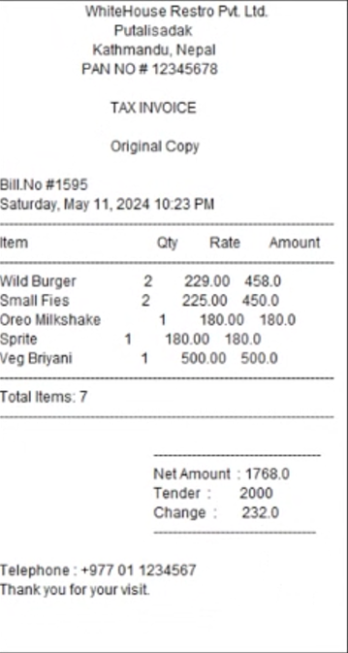

*Figure 12: Bill*

**5. Admin**

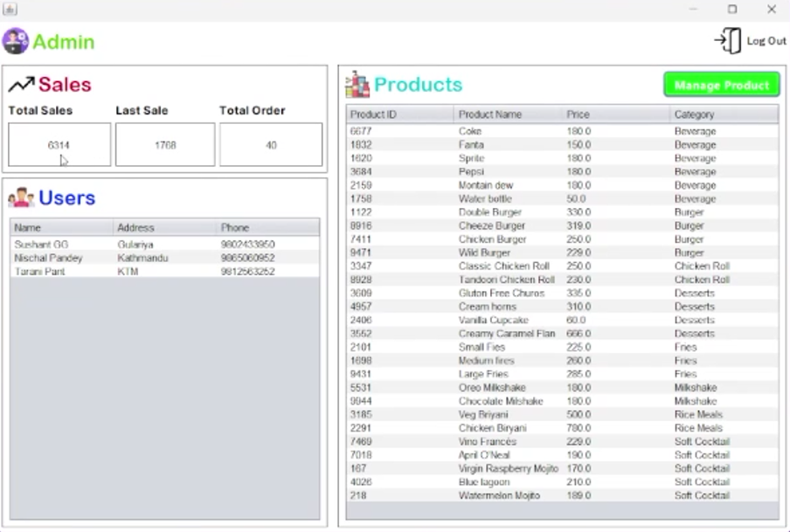

*Figure 13 : Admin page*

**6. Manage Product**

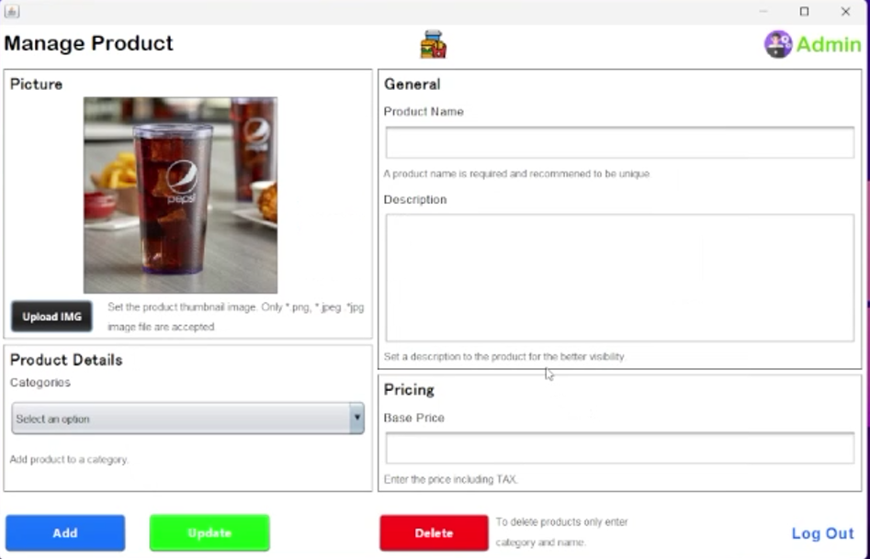

*Figure 14: Manage Product*